16/02689/CND7 - APPENDIX 1

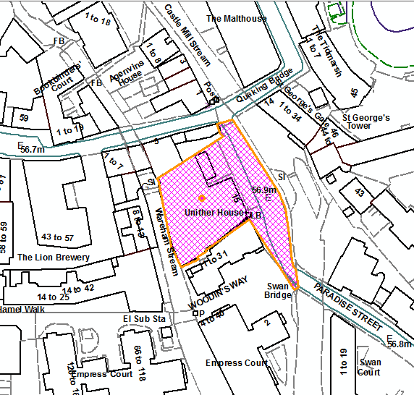 Site Location Plan N

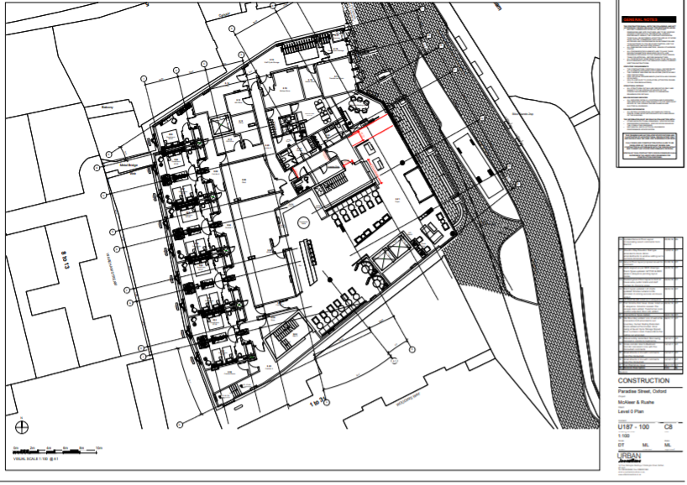
Loading Bay
Site Block Plan N

